**MidTerm Lab Exam Marks (100) - Time (2 Hrs)**

**Multiple Choice Questions (5 Marks)**

Where we configure pluging configuration

a. README.md

b. AndroidManifest.xml c.

c. pubspec.yaml

d. gradlew.bat

Answer: c

A Stateful widget is a dynamic widget which can change the appearance of its content in response to events triggered by user's interactions or when it receives data.

a. True

b. False

Answer: a

Which of the following function or method can be used to add an action to this button if the app user taps this button?

a. GoTo

b. onPressed

c. JumupNow

d. flyTo

Answer: b

This widget helps you to have a specific width and/or height between widgets. Which of the following term is this definition for?

a. AppBar

b. SizedBox

c. SafeArea

d. onChanged

Answer: b

Flutter works with many development tools which are compatible with Flutter plug-ins (Flutter SDK). Which of the following software can be used to build a Flutter app ? (Select three)

a. NotePad

b. Visual Studio

c. IntelliJ

d. Android Studio

Answer: b, c & d

# Answer the Question (25 Marks)

1. Write the step required to register with firebase services.
2. Write the difference between Hot Reload and Hot Restart
3. What is the difference between "main()" and "runApp()" functions in Flutter?
4. When should you use mainAxisAlignment and crossAxisAlignment?
5. Define the Layout Widgets.

# Short Answer Question (25 Marks)

**Question-1**

Consider the following code snippet, where “url” is a string containing the URL of a web service that returns JSON data

*var myResult = await http.get(url);*

Which data type is myResult after executing the code?

**Question-2**

Which method of a navigator object would you use to navigate from the first screen to the second screen?

**Question-3**

Write the name of tools includes in Android Tool bar

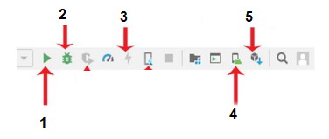

**Question-4**

Add an image from your computer hard disk to GUI. Please write the steps to complete this task.

**Question-5**

Here is a code with Error, Correct it

|  |
| --- |
| RadioButtonGroup(  labelStyle: TextStyle(fontSize: 20),  labels: <String>[  “Small”  “Medium”  “Large”,  ), |

## Write the Code for the following statements (45 Marks)

**Question-1**

You have a raised button in the user interface of your app. When the user taps on the button, you want to print “Contact Us” in the debug console.

Write the code for raised button

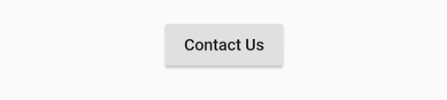

**Question-2**

Write the Code for the following

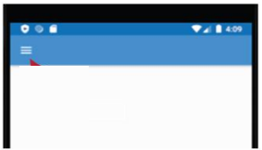

**Question-3**

Write the code used to add floating action button to a Flutter app interface.